Name – Deepraj Santosh Ghadshi

Email ID –deeprajghadshi1920@gmail.com

Assignment no 1

**Q1.**

**wap to demonstrate ternary operator .define a variable marks  .ask its value from user and using ternary operator check if marks > 40 store "Pass" in result varible else store "Fail"**

**Program –**

package assignment1;

import java.util.Scanner;

public class Ternaryopreator {

public static void main(String[] args) {

Scanner s1= new Scanner(System.in);

System.out.print("marks obtain :");

int marks=s1.nextInt();

String result = marks >40 ? "Pass" : "Fail";

System.out.println("you are " + result );

}

}

**Output –**

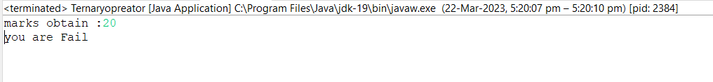

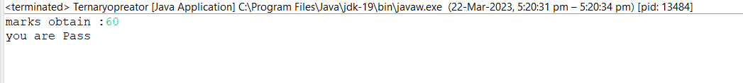

**Q2.**

**Using ternary check if number entered by user is positive or negative .  
In case number is positive store "Positive number" else store negative number to Result variable.**

**Program –**

package assignment1;

import java.util.Scanner;

public class Ternarychecknumber {

public static void main(String[] args) {

Scanner s1= new Scanner(System.in);

System.out.println("marks obtain:");

int num=s1.nextInt();

String result= num>0 ? "positive number" :"negative number" ;

System.out.println(result);

}

}

**Output –**

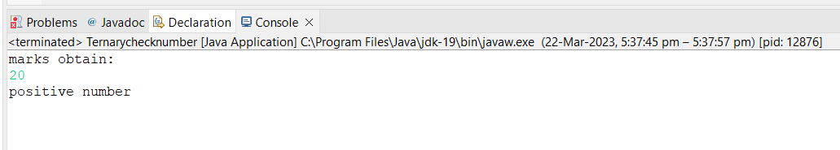

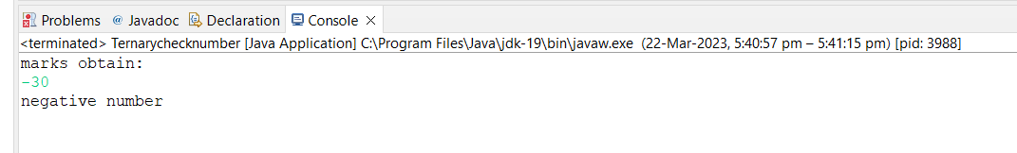

**Q3.**

**WAP to ask name ,age and salary of an employee and print on console.**

**Program –**

**package** assignment1;

**import** java.util.Scanner;

**public** **class** Efelse {

**public** **static** **void** main(String[] args) {

Scanner sc = **new** Scanner(System.***in***);

String name;

System.***out***.print("Enter name: ");

name = sc.nextLine();

**int** age;

System.***out***.print("Enter age: ");

age = sc.nextInt();

**double** salary;

System.***out***.print("Enter salary: ");

salary = sc.nextDouble();

System.***out***.println("Name: " + name);

System.***out***.println("Age: " + age);

System.***out***.println("Salary: " + salary);

}

}

**Output –**

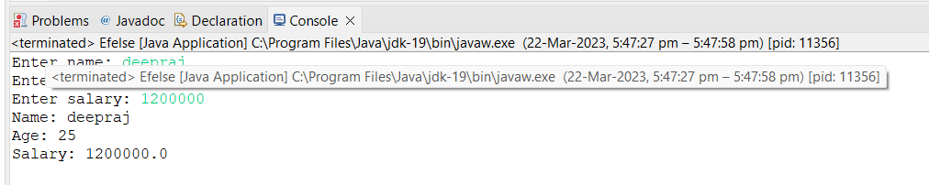

**Q4.**

**wap  that ask two numbers from user and print greater number among two**

**Program –**

**package** assignment1;

**import** java.util.Scanner;

**public** **class** Graternumber {

**public** **static** **void** main(String[] args) {

Scanner sc = **new** Scanner(System.***in***);

**int** num1;

System.***out***.print("Enter num1: ");

num1 = sc.nextInt();

**int** num2;

System.***out***.print("Enter num2: ");

num2 = sc.nextInt();

**if** ( num1>num2)

{

System.***out***.println(num1);

}

**else**

{

System.***out***.println(num2);

}

}

}

**0utput –**

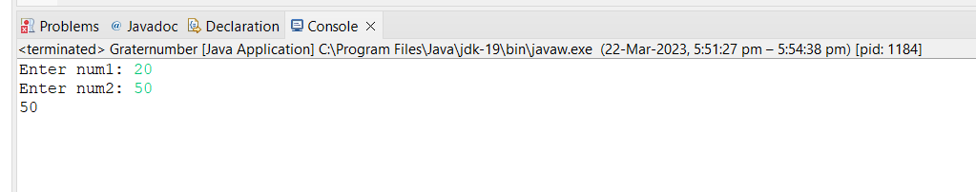

**Q5.**

**wap to ask product name and price of product from user and calculate discount i.e   
if price > 2000 then discount is 10 percent of price   
else   
discount is 7 % of price**

**Program –**

package assignment1;

import java.util.Scanner;

public class discount {

public static void main(String[] args) {

Scanner s = new Scanner(System.in);

double discount,finalprice;

String name;

System.out.print("Enter name: ");

name = s.nextLine();

int initialprice;

System.out.print("Enter num1: ");

initialprice = s.nextInt();

if(initialprice >=2000)

{

discount = 0.1 * initialprice;

// finalprice= initialprice-discount;

//System.out.println(discount);

}

else

{

discount = 0.07 * initialprice;

// finalprice= initialprice-discount;

//System.out.println(discount);

}

finalprice= initialprice-discount;

System.out.println(discount);

}

}

**0utput –**

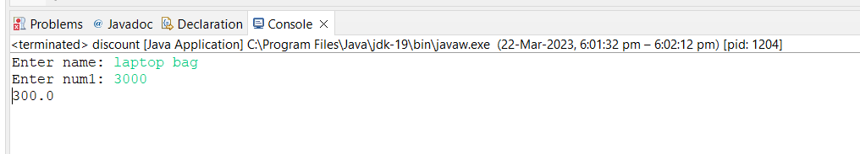

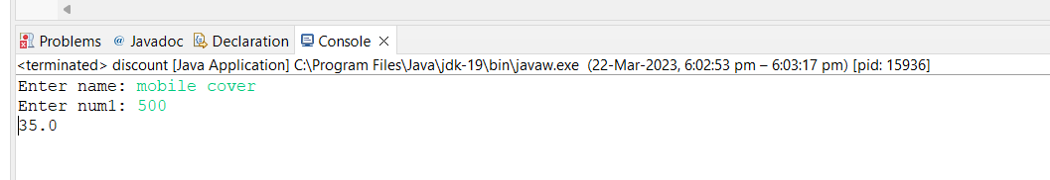

**Q6.**

**Wap to swap two numbers**

**Program –**

**package** assignment1;

// Wap to swap two numbers

**public** **class** Swaptwonum {

**public** **static** **void** main(String[] args) {

**int** a=5;

**int** b=10;

System.***out***.println("Before swaping the numbers :");

System.***out***.println("First number :" + a);

System.***out***.println("Second number :" +b);

**int** temp=a;

a=b;

b=temp;

System.***out***.println("After swaping the numbers :");

System.***out***.println("First number :" + a);

System.***out***.println("Second number :" +b);

}

}

**0utput –**

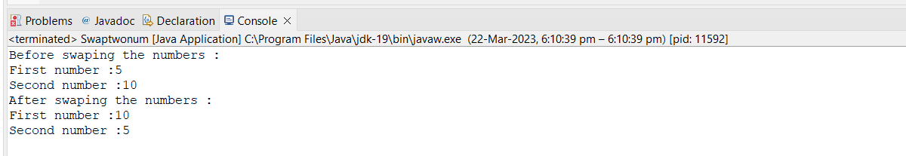

**Q7.**

**How to swap two numbers without using a third variable?**

**Program –**

**package** assignment1;

**public** **class** Swapnovariable {

**public** **static** **void** main(String[] args) {

**int** a=20;

**int** b=45;

System.***out***.println("Before swaping the numbers :");

System.***out***.println("First number :" + a);

System.***out***.println("Second number :" +b);

a=a+b; // 20+45=65

b=a-b; // 65-45=20

a=a-b; //65-20=45

System.***out***.println("Before swaping the numbers :");

System.***out***.println("First number :" + a);

System.***out***.println("Second number :" +b);

}

}

**0utput –**

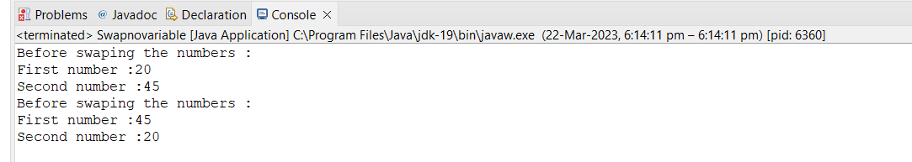

**Q8.**

**wap to check is number is even or odd.**

**Program –**

**package** assignment1;

**import** java.util.Scanner;

**public** **class** Evenorodd {

**public** **static** **void** main(String[] args) {

Scanner s = **new** Scanner(System.***in***);

System.***out***.print("Enter number :");

**int** num=s.nextInt();

**if**(num%2==0)

System.***out***.println(" the number is even");

**else**

System.***out***.println("the number is odd");

}

}

0utput –

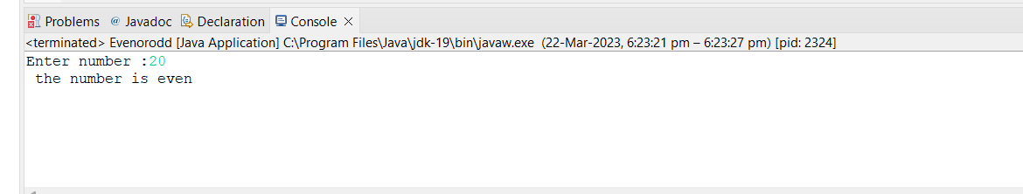

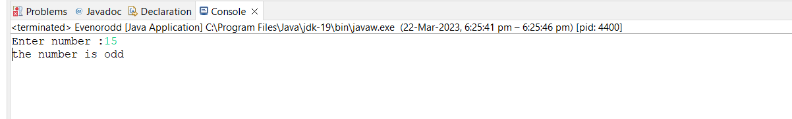

**Q9.**

**A school has following rules for grading system:  
 a. Below 25 - F  
 b. 25 to 45 - E  
 c. 45 to 50 - D  
 d. 50 to 60 - C  
 e. 60 to 80 - B  
 f. Above 80 - A  
 Ask user to enter marks and print the corresponding grade**

**Program –**

**package** assignment1;

/*A school has following rules for grading system:

a. Below 25 - F

b. 25 to 45 - E

c. 45 to 50 - D

d. 50 to 60 - C

e. 60 to 80 - B

f. Above 80 - A0

Ask user to enter marks and print the corresponding grade */

**import** java.util.Scanner;

**public** **class** Gradingsystem {

**public** **static** **void** main(String[] args) {

Scanner s = **new** Scanner(System.***in***);

System.***out***.print("Enter number :");

**int** num=s.nextInt();

**if**(num<=25)

System.***out***.println("F");

**else** **if**(num<=45)

System.***out***.println("E");

**else** **if**(num<=50)

System.***out***.println("D");

**else** **if**(num<=60)

System.***out***.println("C");

**else** **if**(num<=80)

System.***out***.println("B");

**else** **if**(num>80)

System.***out***.println("A");

}

}

**0utput –**

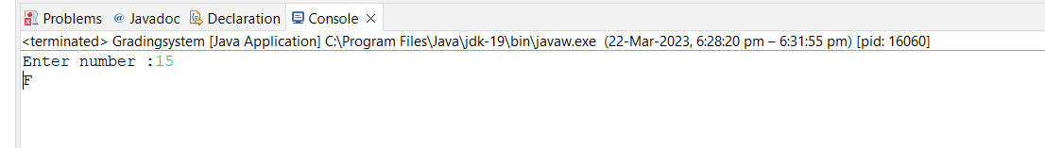

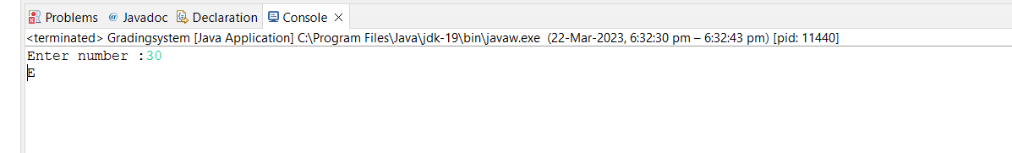

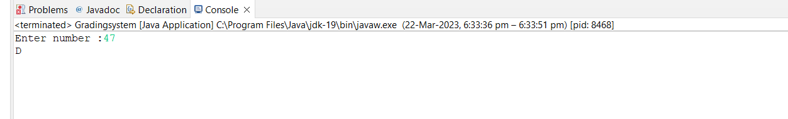

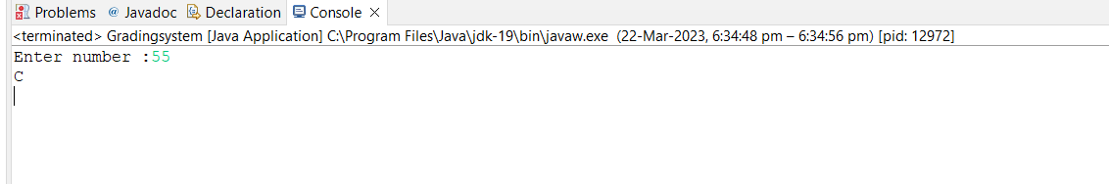

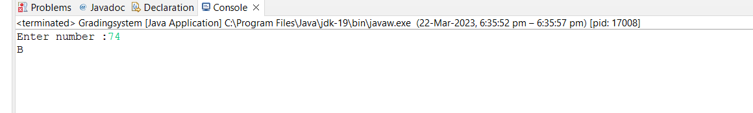

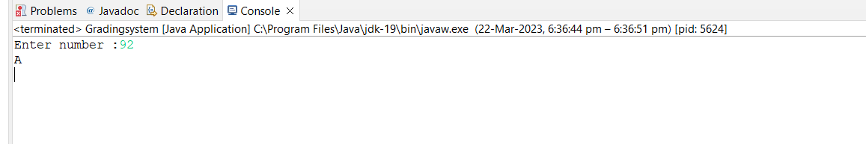

**Q10.**

**wap to check greater number among three numbers**

**Program –**

**package** assignment1;

**import** java.util.Scanner;

/*wap that ask two numbers from user and print greater number among two */

**public** **class** maximumnumber {

**public** **static** **void** main(String[] args) {

Scanner s = **new** Scanner(System.***in***);

**int** num1;

System.***out***.print("Enter number1:");

num1= s.nextInt();

**int** num2;

System.***out***.print("Enter number2:");

num2= s.nextInt();

**int** num3;

System.***out***.print("Enter number3:");

num3= s.nextInt();

**int** maxresult = (num1>=num2) ? ((num1>=num2)?num1:num2) :((num2>=num3)?num2:num3 );

//int maxresult = (num1<=num2) ? ((num2>=num3)?num2:num3) : ((num1>=num3)?num1:num3);

System.***out***.println(maxresult);

}

}

**0utput –**

